**July 24, 2023**

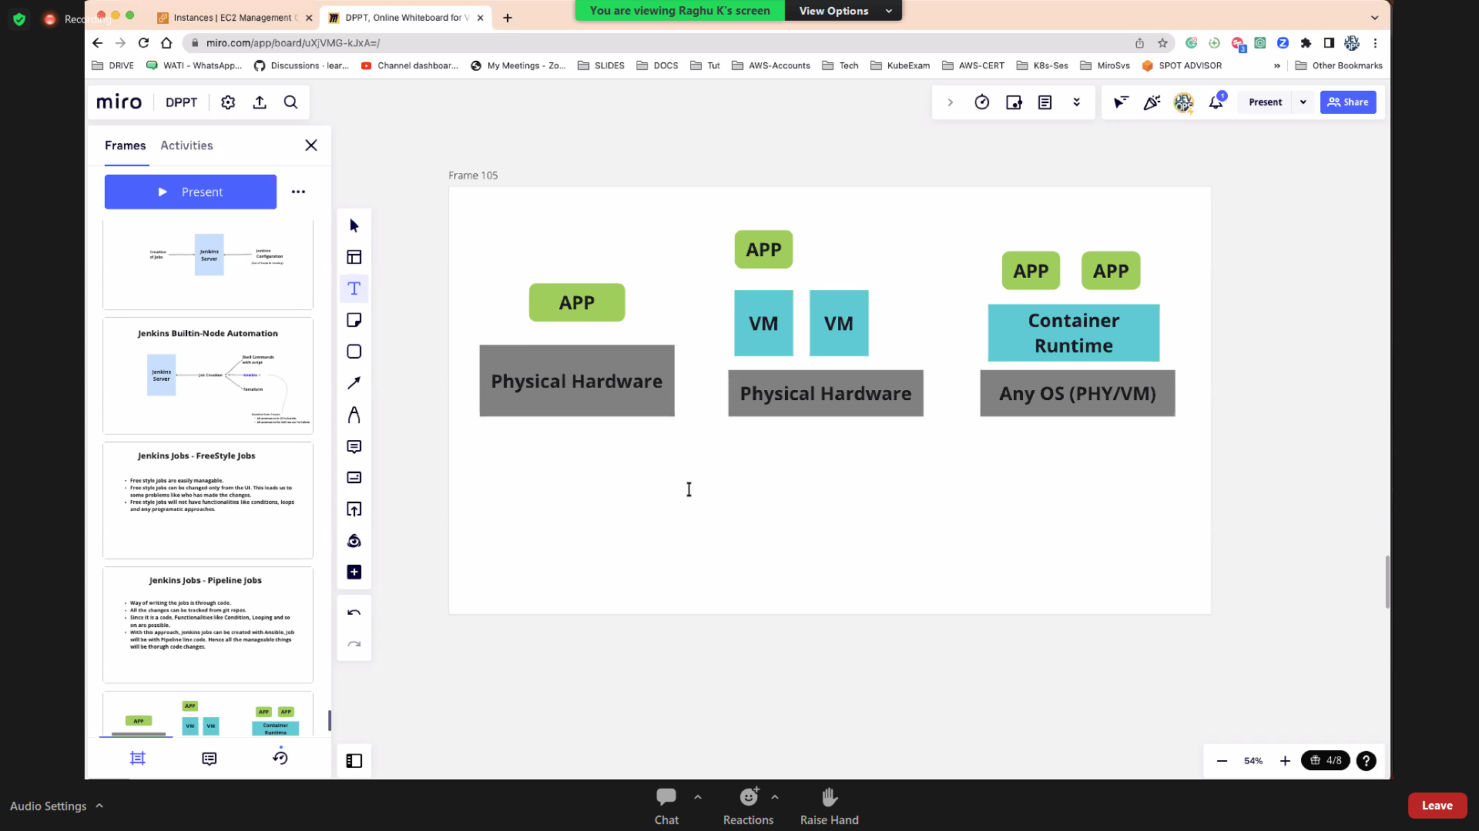

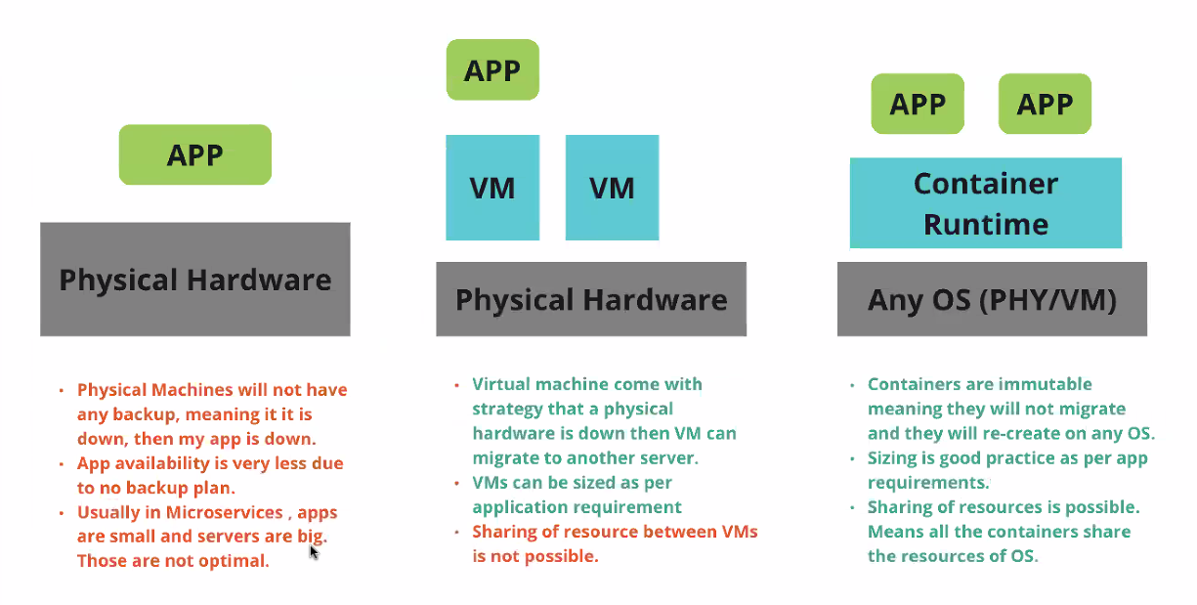

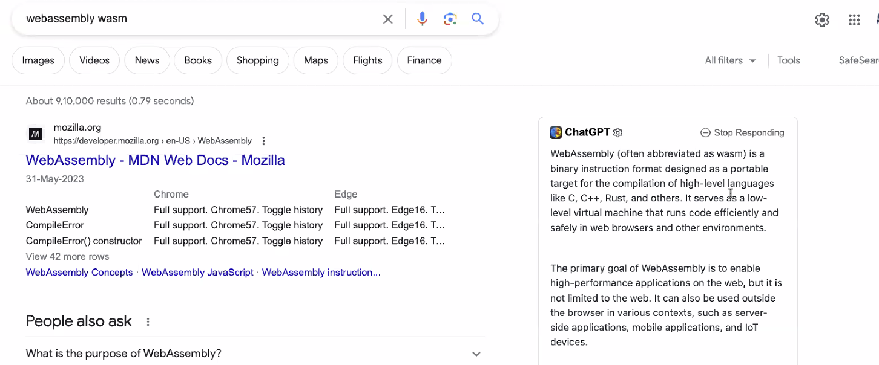

**Docker Founder only found WASM**

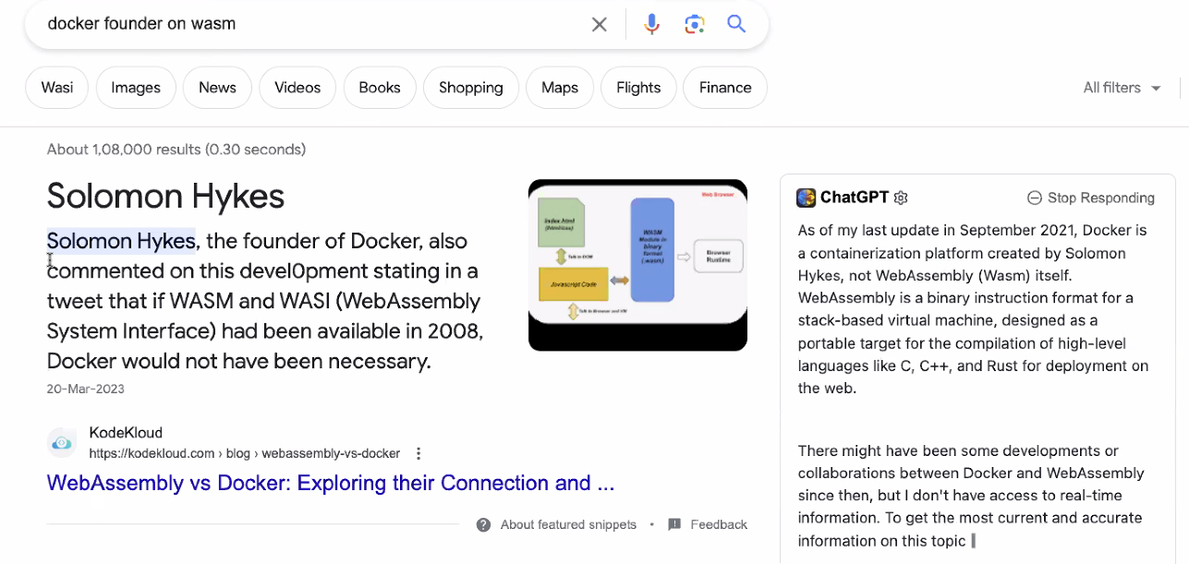

**Different Containers:**

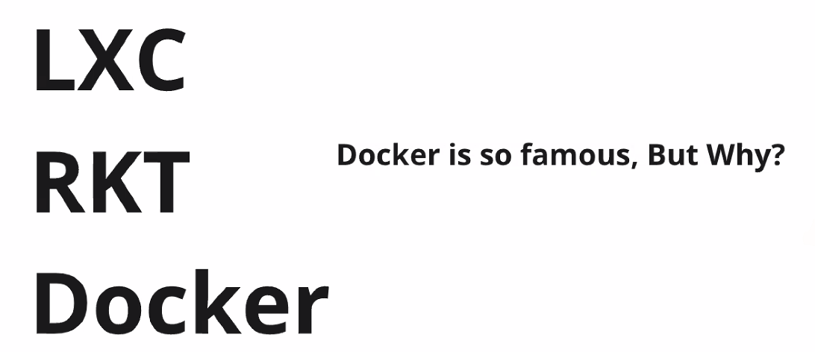

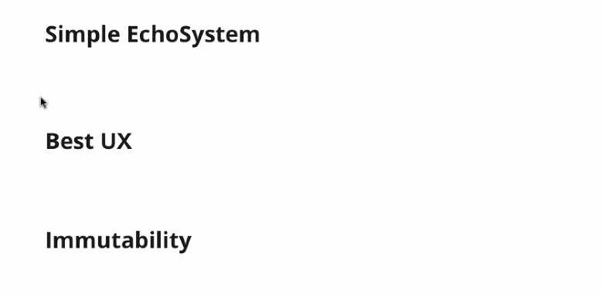

**3 docker versions**

* **Community version**
* **Enterprise Edition**
* **Open-Source Edition**

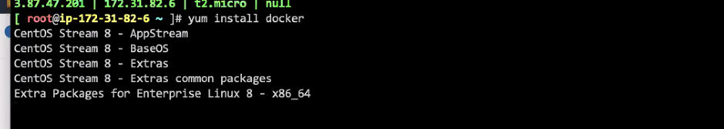

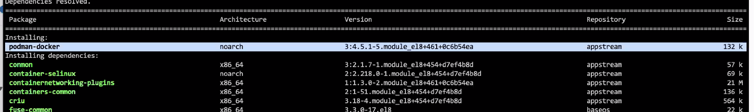

Podman vs.

Docker is a containerization technology that enables the creation and use of Linux containers. The main difference between Podman and Docker is Podman's daemonless architecture. Podman containers have always been rootless, while Docker just recently added a rootless mode to its daemon configuration

What is difference between Docker and podman?



Docker runs on a client-server that is meditated by the daemon that leverages REST APIs to request to perform container-related operations. Podman, on the other hand, does not require a daemon. It uses Pods to manage containers, which helps users to run rootless containers.

**So we don’t want to go with PODMAN,**

Note: We can install using curl

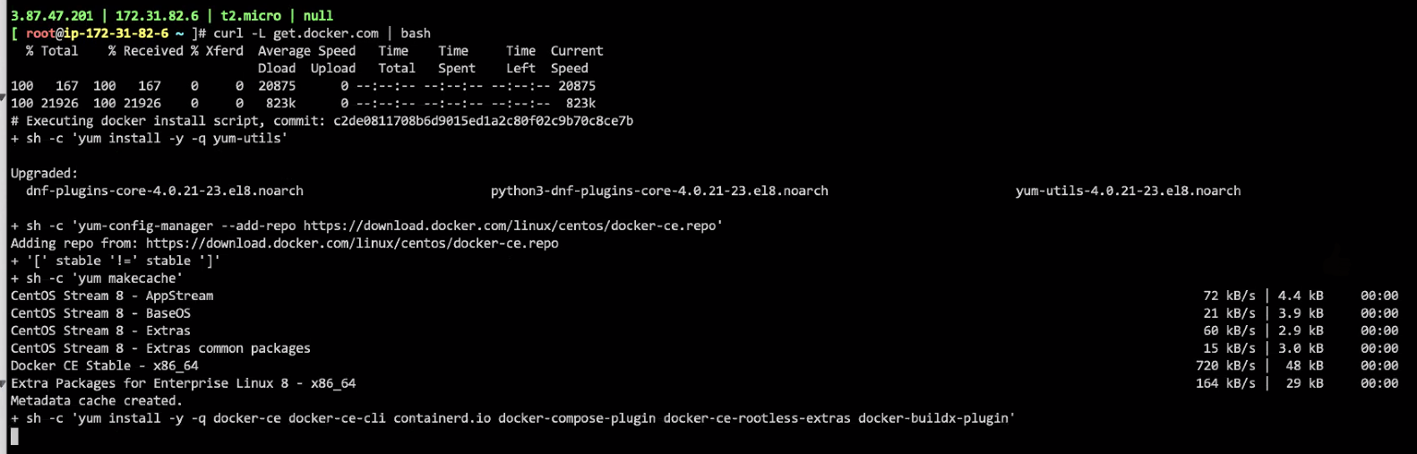

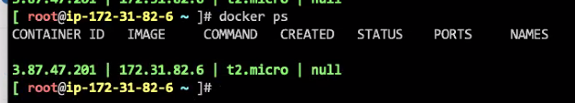

**My Practice:**

curl -L get.docker.com | bash

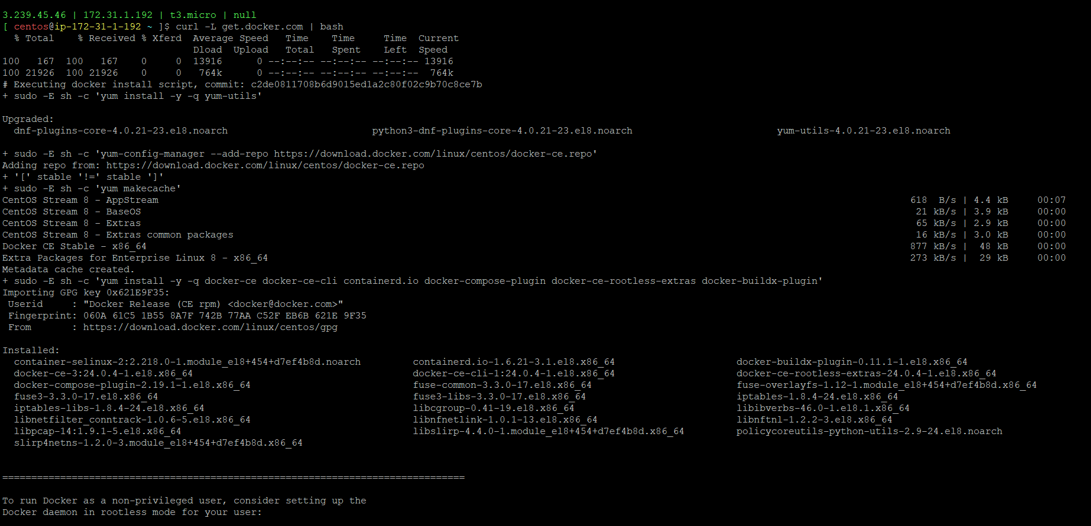

After installation of docker, we need to start and enable with the admin rights.

Systemctl start docker

Systemctl enable docker

Docker ps

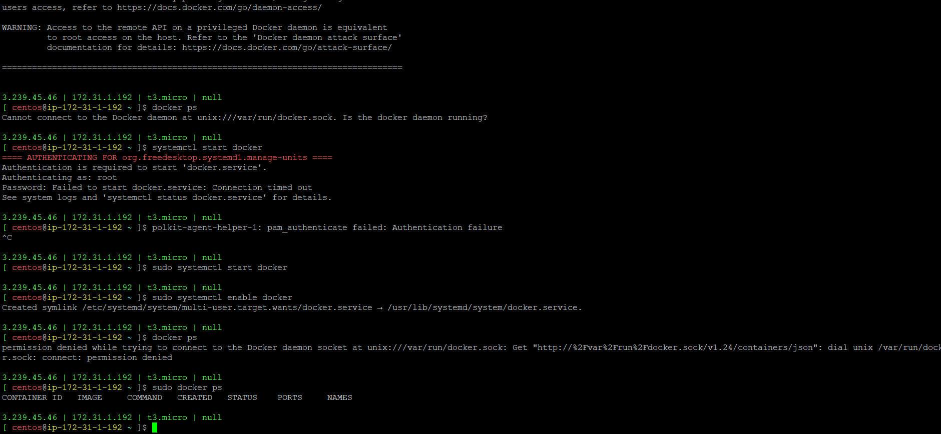

**July 25, 2023**

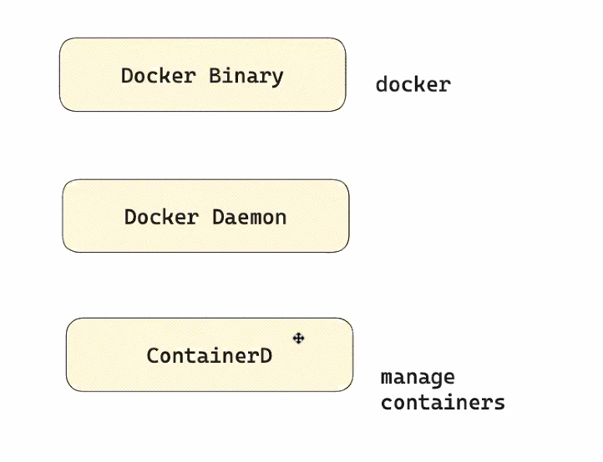

Docker Service/Daemon

Container D containers

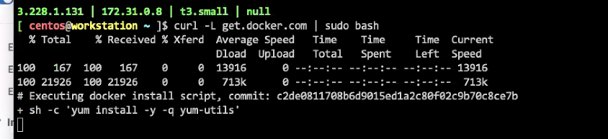

curl -L get.docker.com | sudo bash

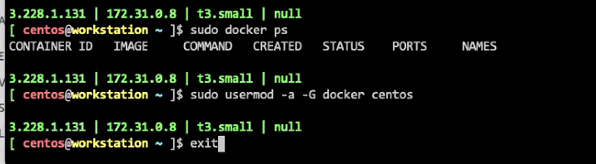

**Note: Need to add usermod**

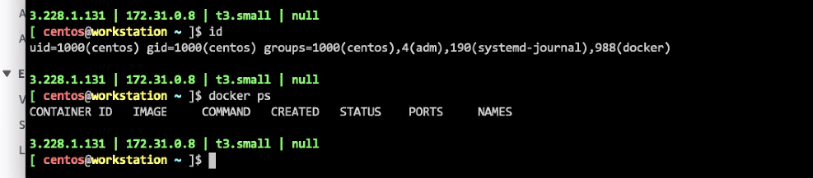

sudo usermod -a -G docker centos

public images will be available at hub.docker.com

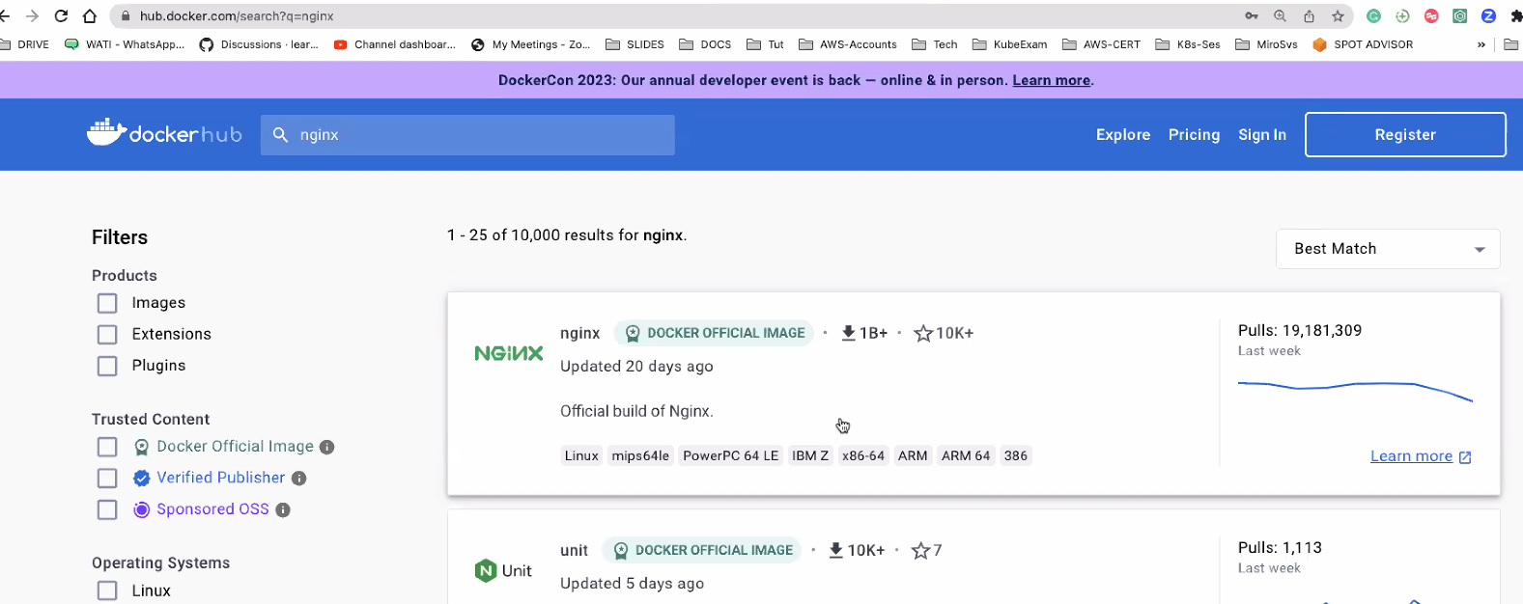

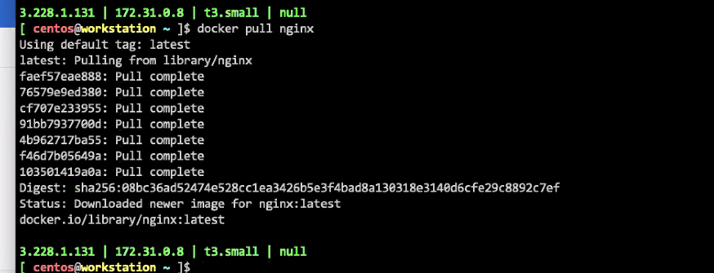

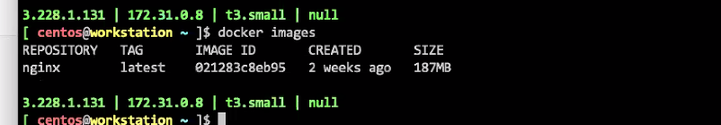

Many nginx versions are available, then go with a stable version so that we will not face any security issues.

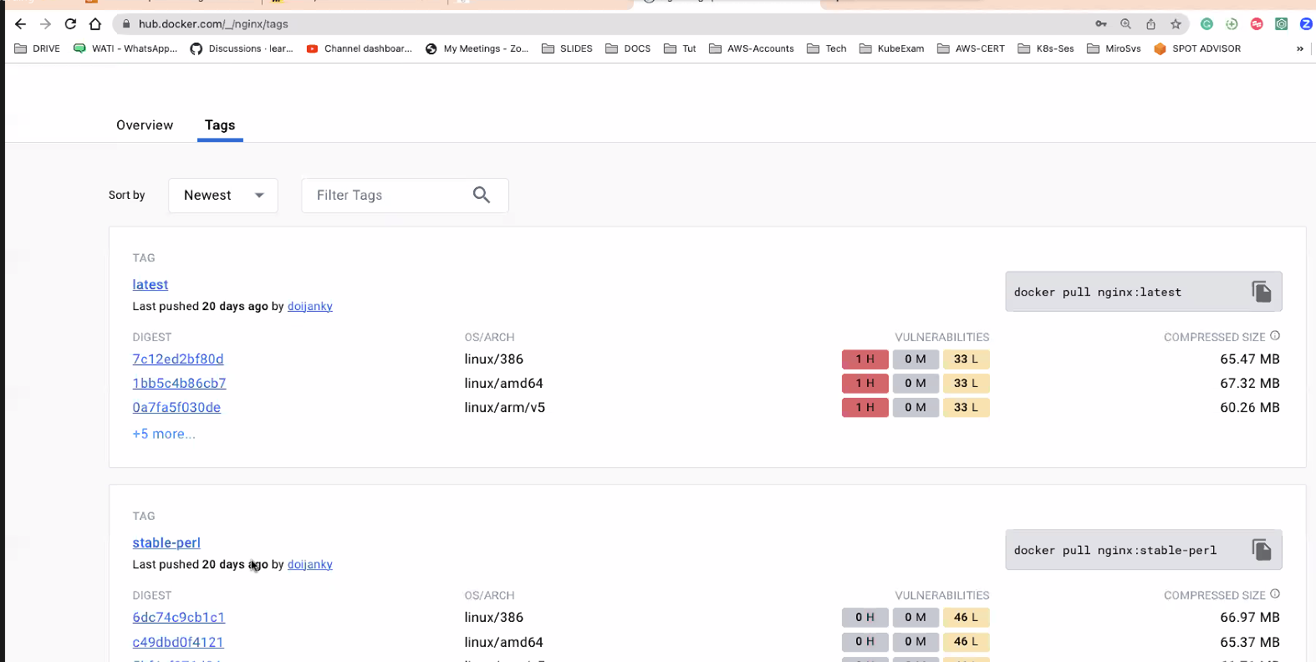

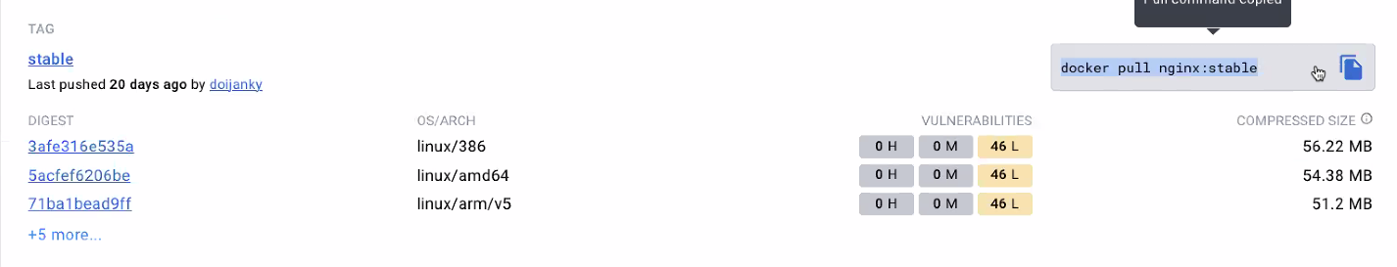

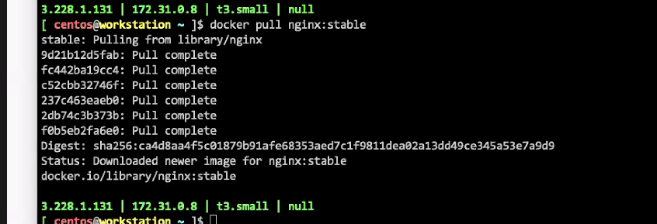

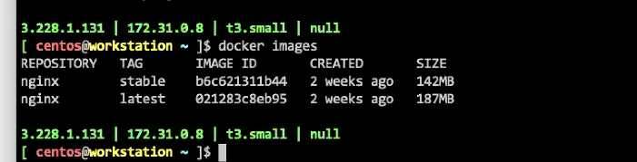

To remove image

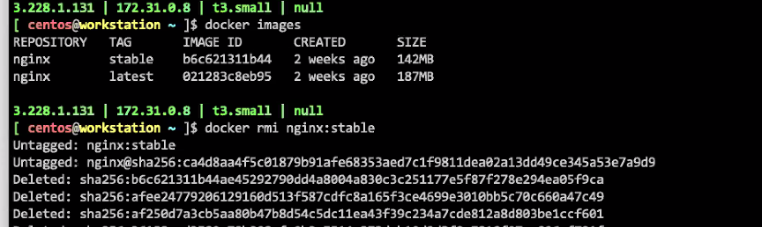

run is a command to lunch a container

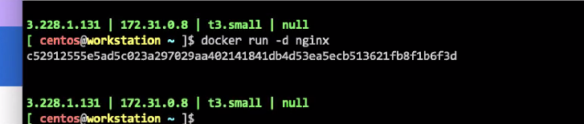

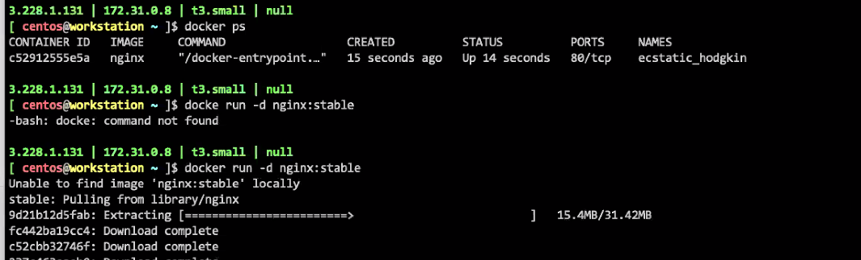

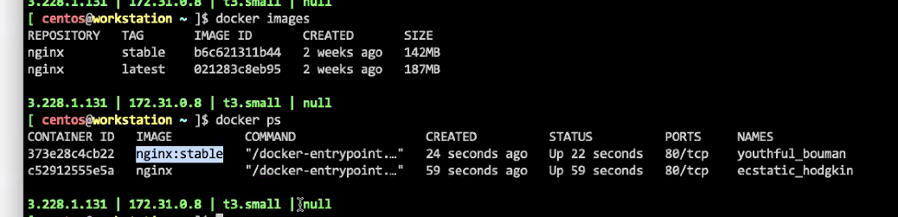

We can use Dockerfile to make images like as JenkinsFile

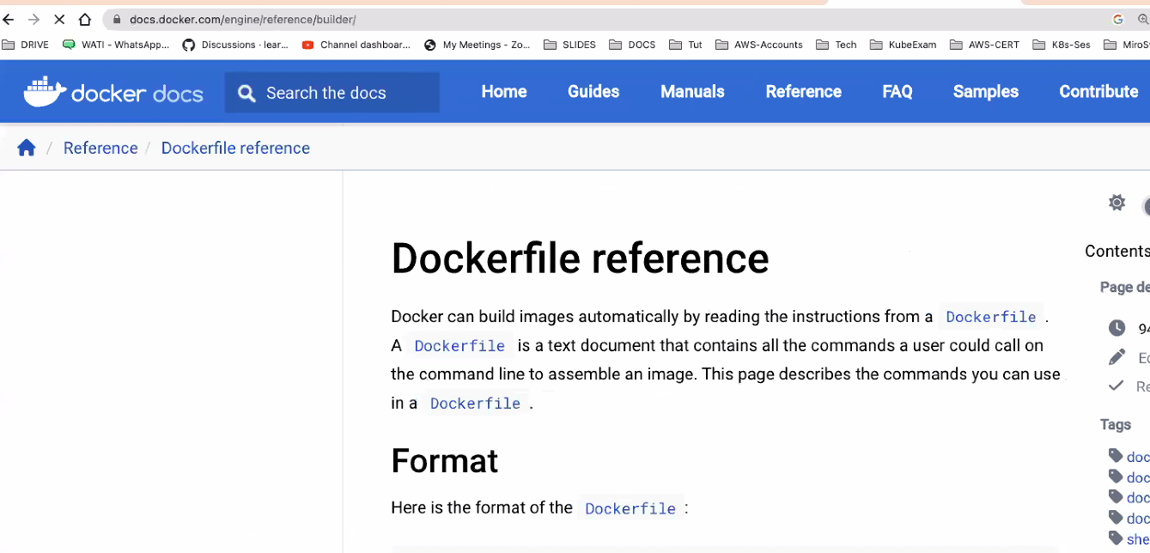

**Instructions**

FROM nginx

Example:

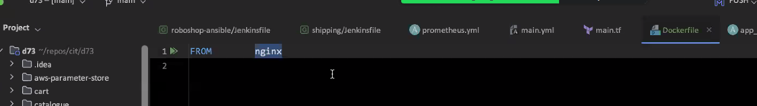

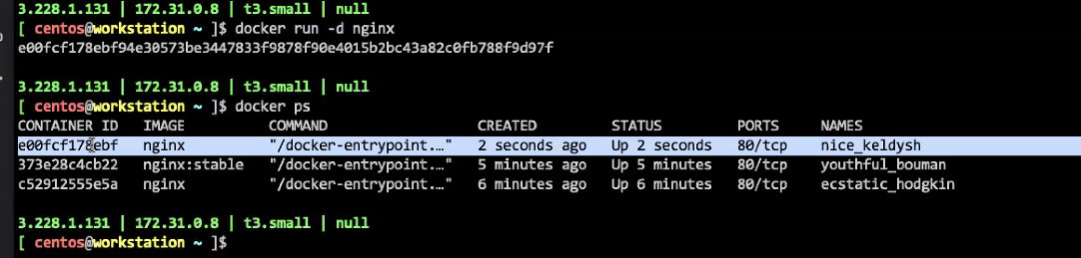

GO inside a container with exec command

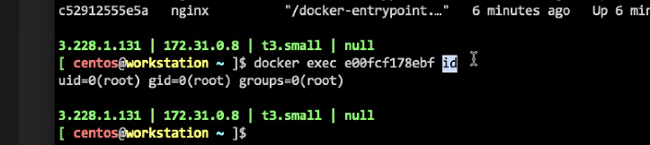

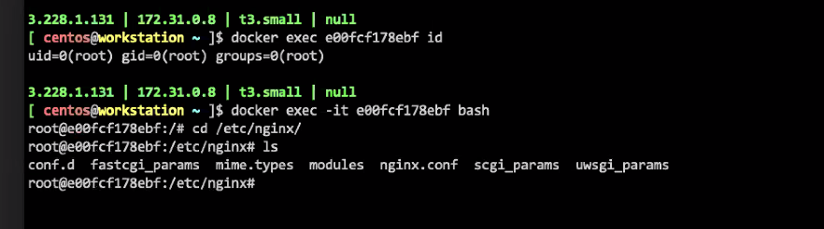

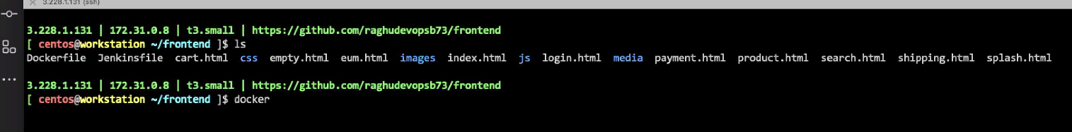

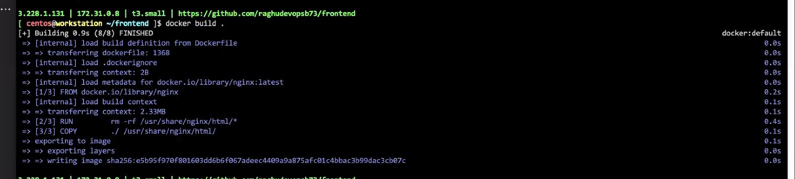

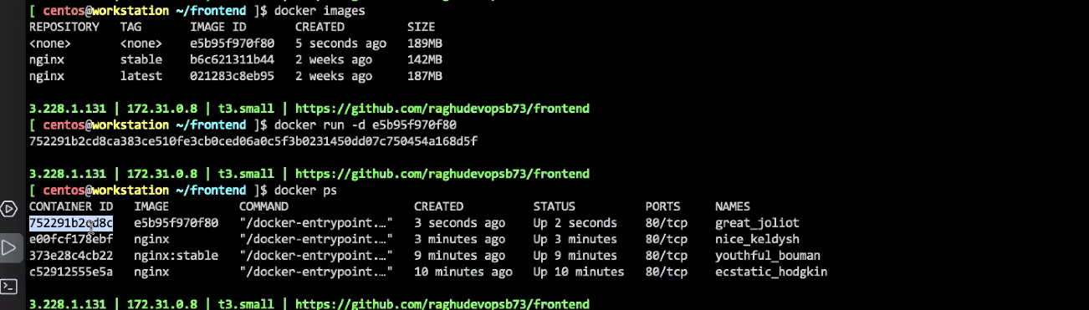



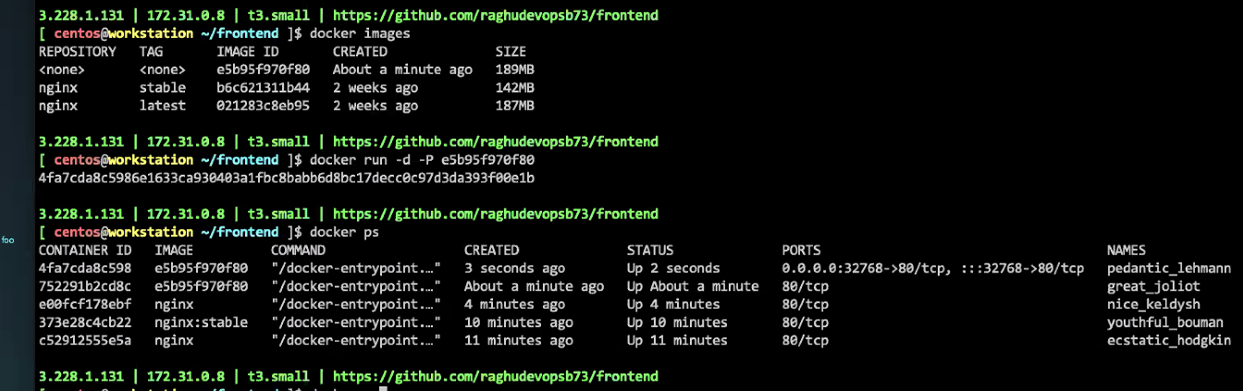

-P publish and -p change a port

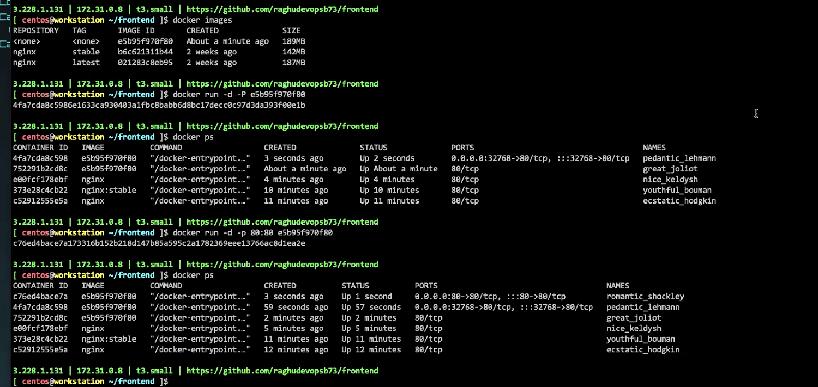

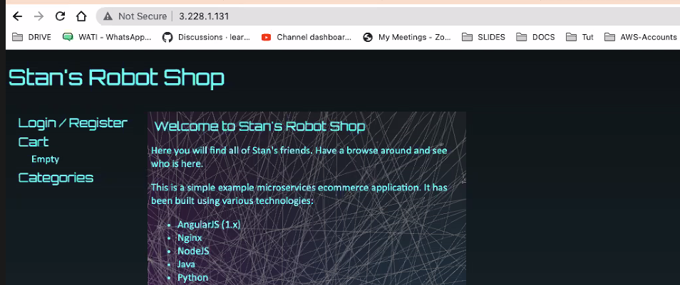

After adding configuration

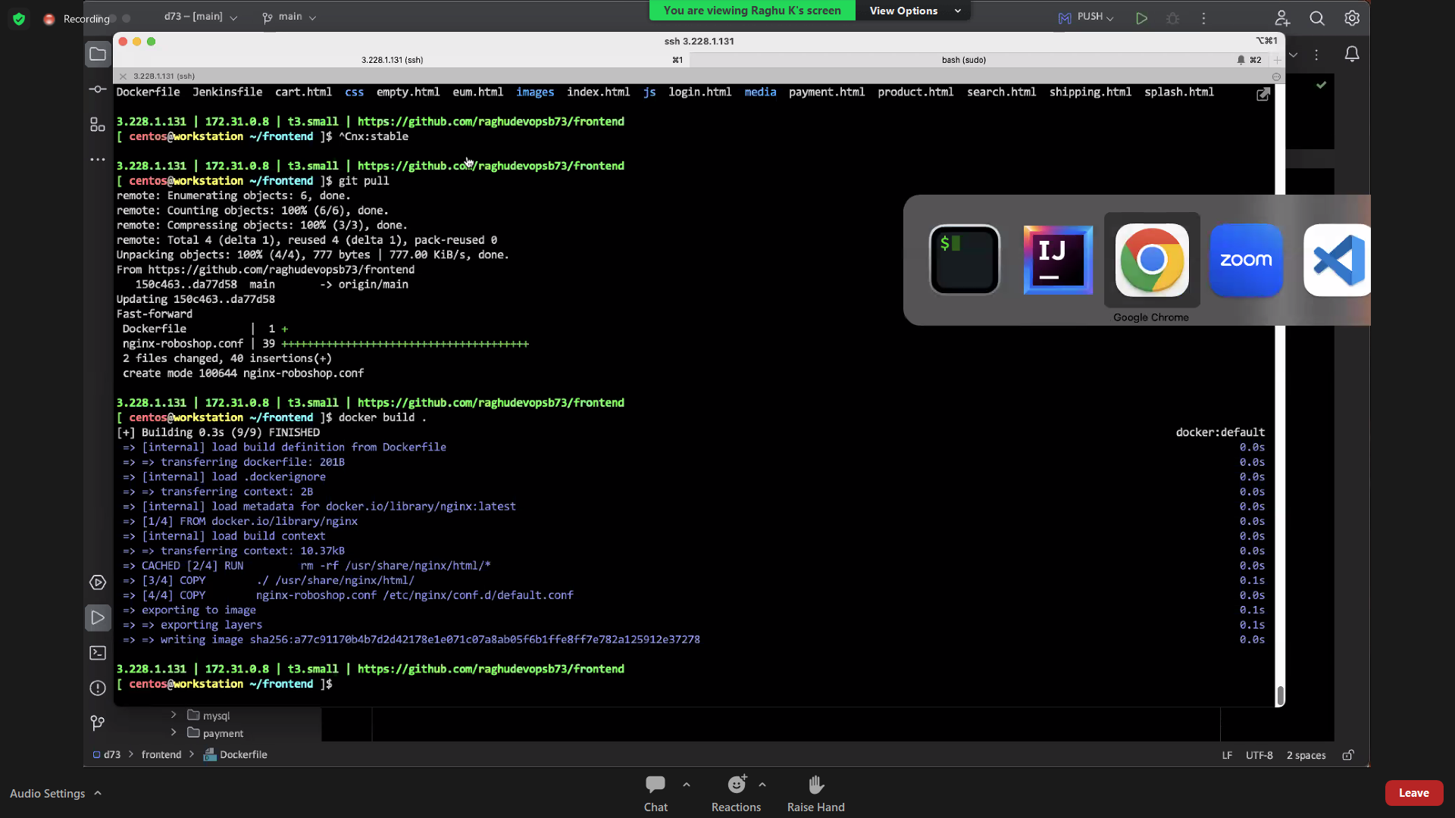

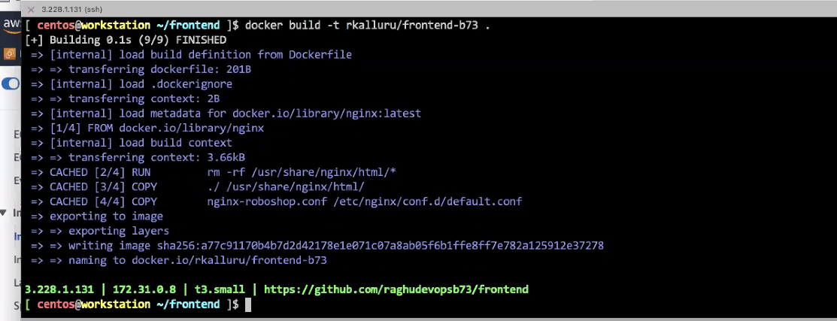

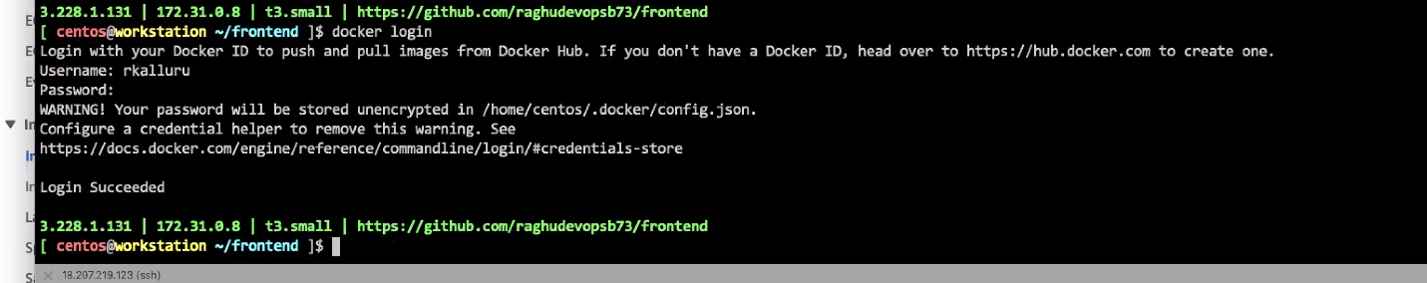

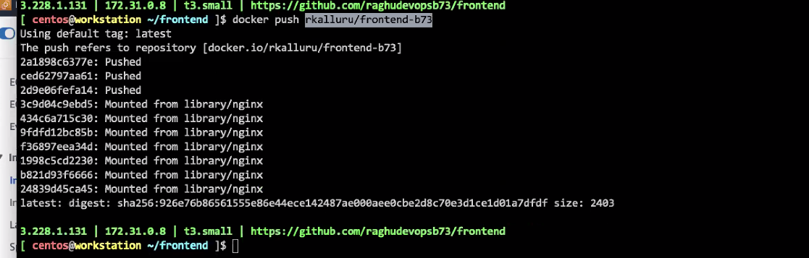

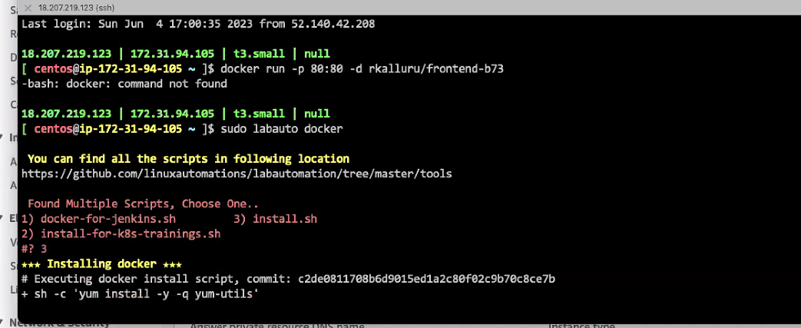

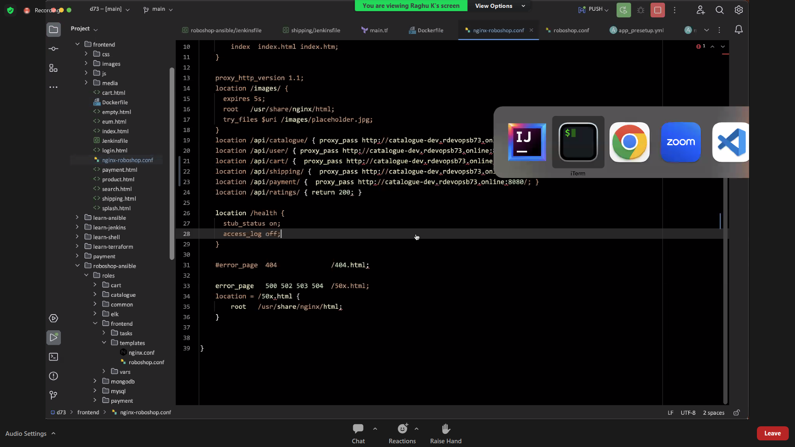

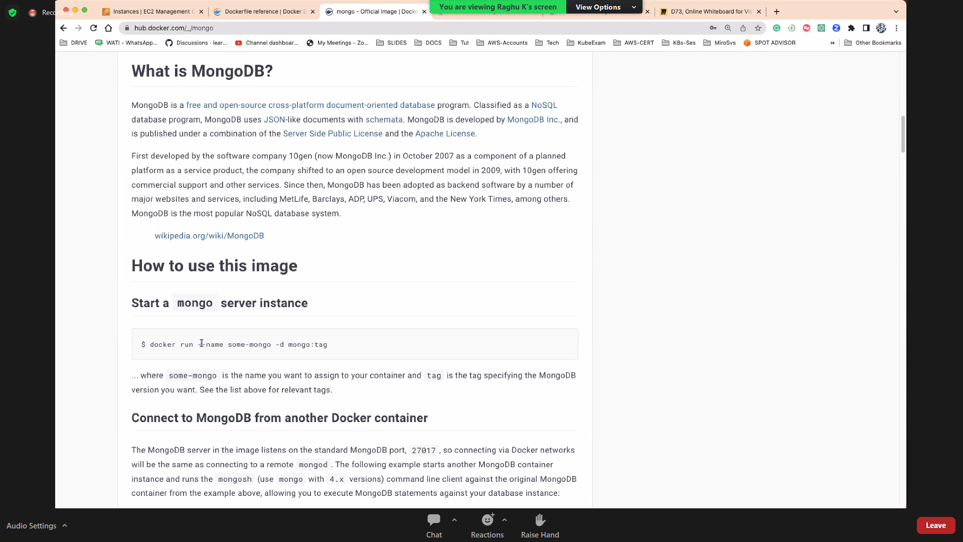

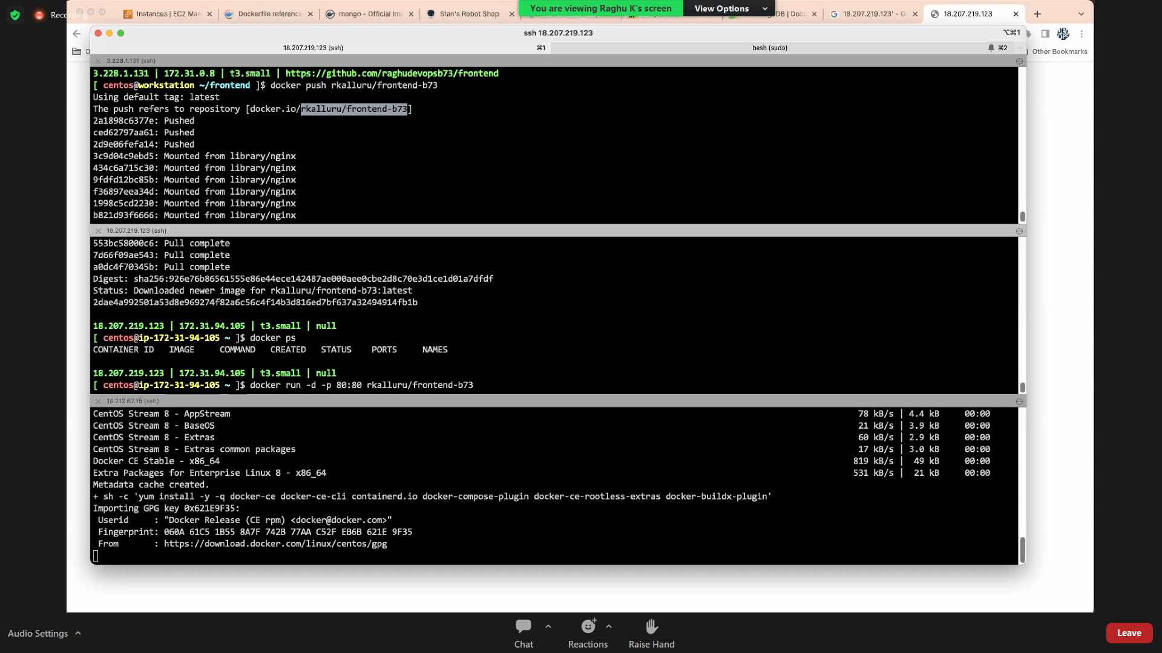

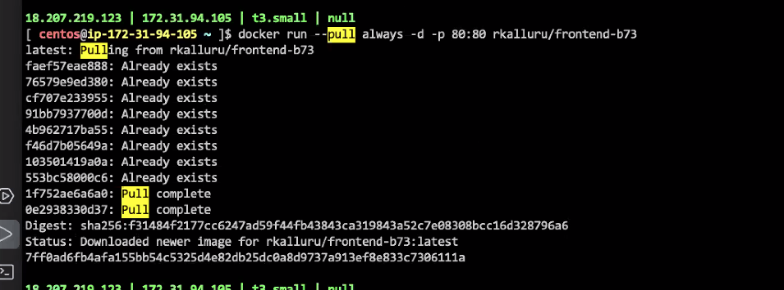

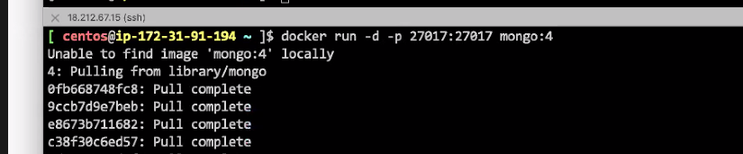

Next module:

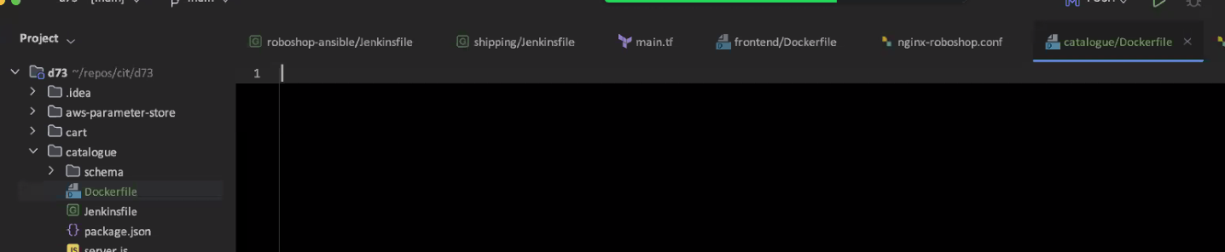

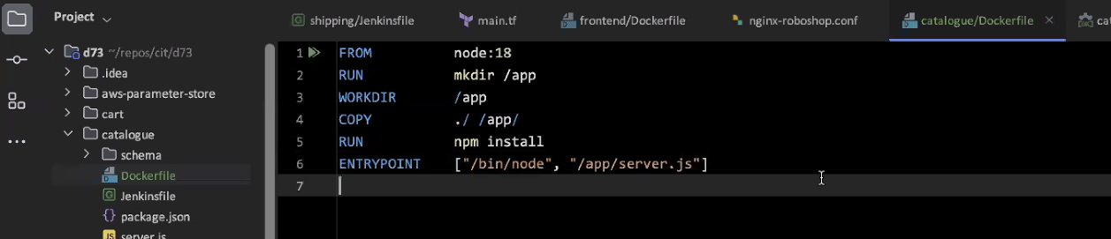

To see or check the space

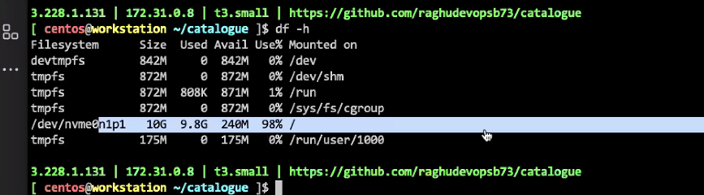

Increase a memory or space on workstation,

Stop the instance

Storage

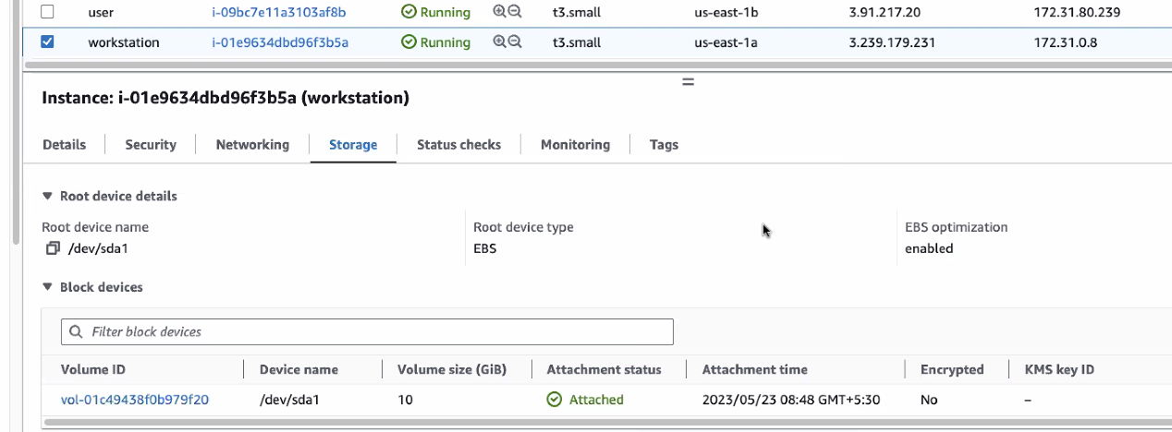

Change the volume

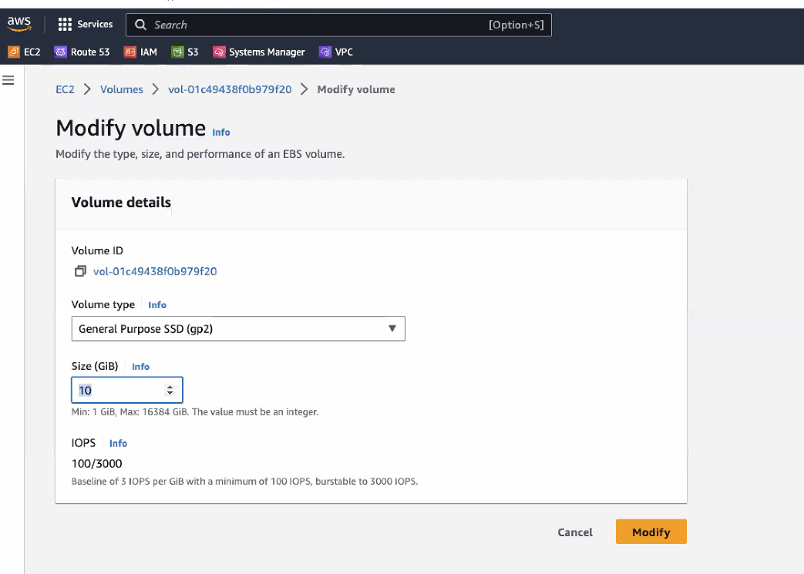

And then start the instance and check it

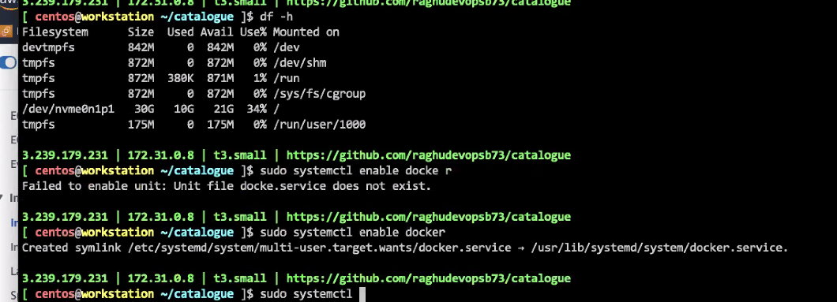

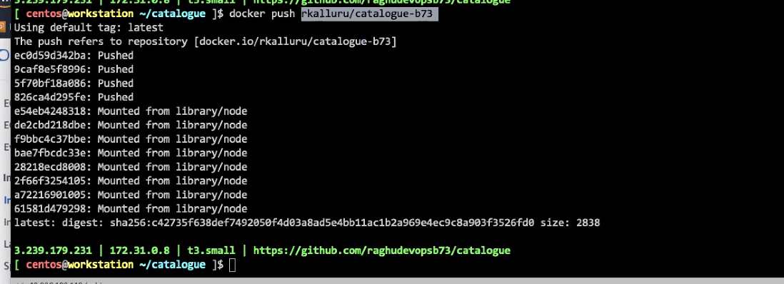

Pull the image in a different instance

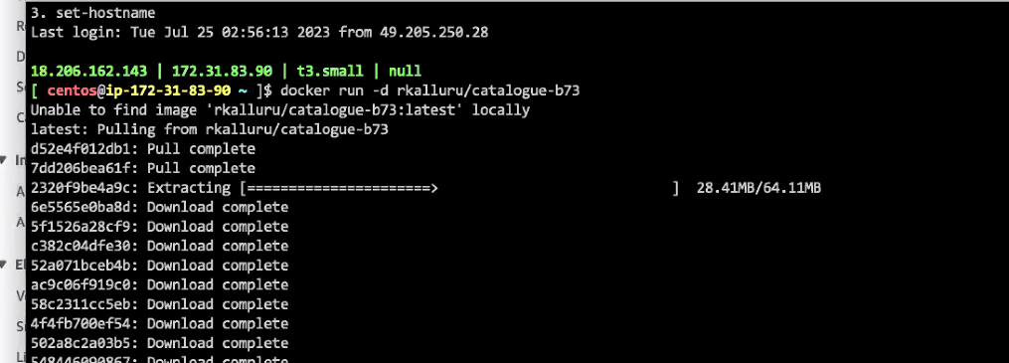

PUSH and PULL images in 2 instances

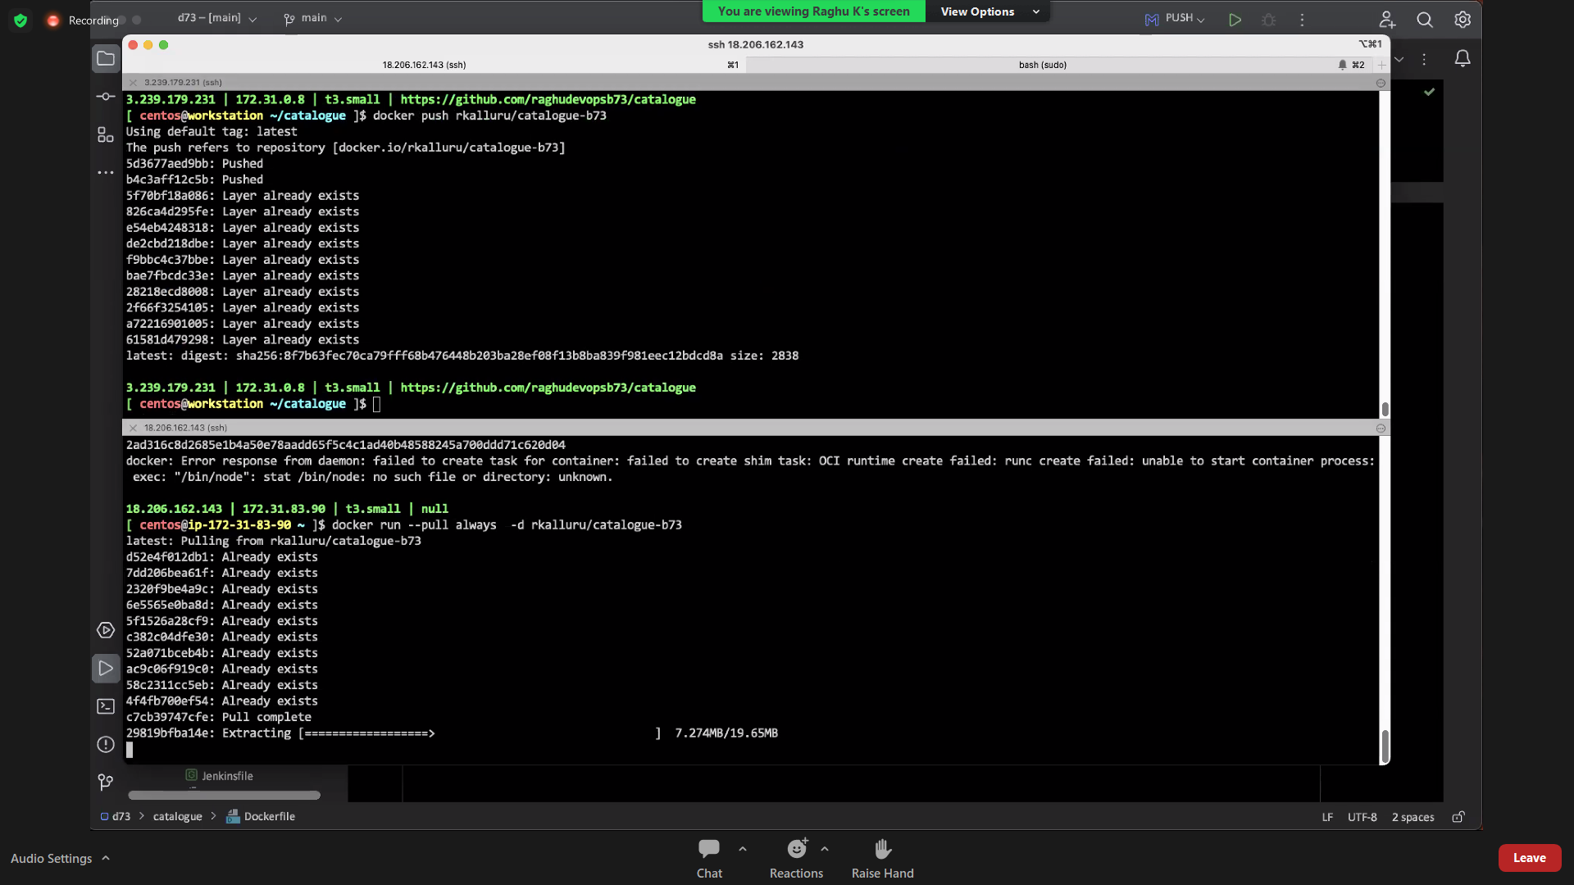

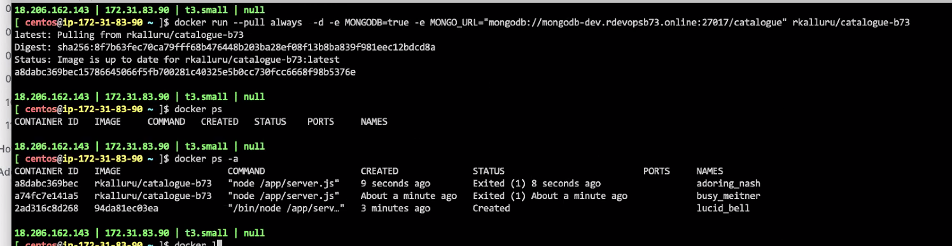

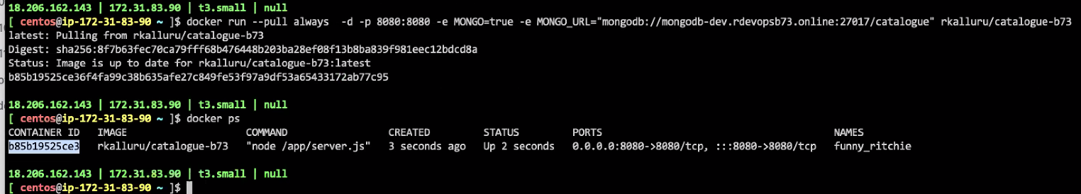

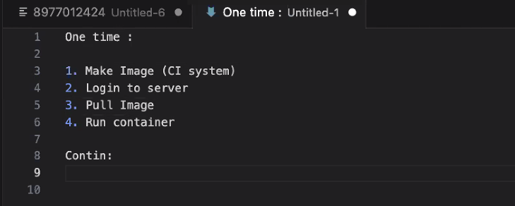

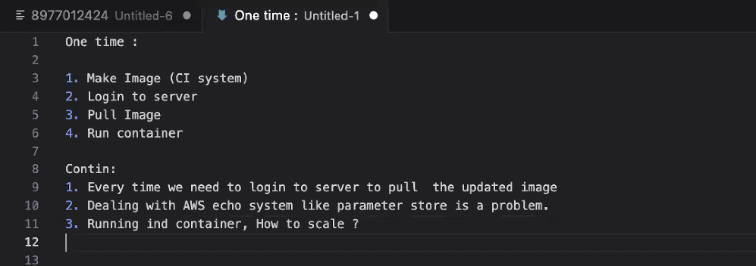

To deal with these issues so we need to go for orchestration tools like K8S

